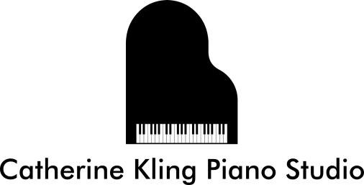

Application for Enrollment

Name of Student: ____________________________________________________

Length of Lesson: 30 minutes 45 minutes 60 minutes

Parents (if student is a child): ___________________________________________

Address: ___________________________________________________________

City: ________________________________ Zip: _________________________

Phone (home): ___________________ Cell: _____________________________

Work: __________________________

Email(s): ___________________________________________________________

Previous Music Study (where, when, how long):_____________________________

___________________________________________________________________

Do you currently study any other instruments? Yes No

If yes, what instrument and where? ______________________________________

What is your goal in taking lessons? _____________________________________

___________________________________________________________________

___________________________________________________________________

Learning styles or other information that will be helpful in the instruction of piano: __

___________________________________________________________________

Do you have a keyboard? Yes No

If yes, describe (acoustic or digital, weighted action, number of keys, pedals): ______

____________________________________________________________________

____________________________________________________________________

If no, will you obtain a keyboard in the near future (as in days)? Yes No

Would you like to have your lessons audio recorded and the file sent to you for reference between lessons? Yes No

If yes, e-mail of computer to be used for listening to recordings: _________________

____________________________________________________________________

